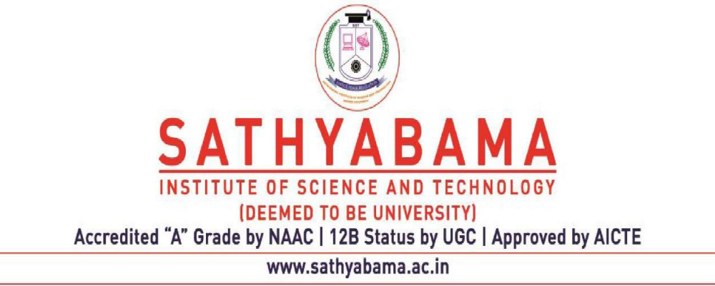

7.1.10_ Web-Link to the relevant documents on the HEI website

ROTARACT club has conducted a TRAFFIC AWARENESS PROGRAM by Mr. M.Kumar , Traffic Police Sholinganallur junction on 2nd March, 2019. Students are given insight about Traffic Rules and Responsibilities of Road safety.
https://www.sathyabama.ac.in/node/402#:~:text=ROTARACT%20club%C2%A0%20has%20conducted%20a%20TRAFFIC%20AWARENESS%20PROGRAM%20by%C2%A0%20Mr.%20M.Kumar%20%2C%20Traffic%20Police%20Sholinganallur%20junction%C2%A0%20on%202nd%20March%2C%202019.%20Students%20are%20given%20insight%20about%20Traffic%20Rules%20and%20Responsibilities%20of%20Road%20safety.

The Community Development Club organized an "Awareness programme on Organ Donation" in association with MOHAN Foundation for the second year students on 14th February 2018.
https://www.sathyabama.ac.in/node/389#:~:text=The%20Community%20Development%20Club%20organized%20an%20%22Awareness%20programme%20on%20Organ%20Donation%22%20in%20association%20with%20MOHAN%20Foundation%20for%20the%20second%20year%20students%20on%2014th%20February%202018.

Zero wastage, an initiative made by the club students to create an awareness of the wastage of food in the mess.
https://www.sathyabama.ac.in/node/389#:~:text=Zero%20wastage%2C%20an%20initiative%20made%20by%20the%20club%20students%20to%20create%20an%20awareness%20of%20the%20wastage%20of%20food%20in%20the%20mess.

Eco Club of Sathyabama Institute of Science and Technology conducted "ECO-ENZYME" - An environmental awareness session on 7th January, 2022. Ms.Shawani Shome shared her learning experiences with students.
https://www.sathyabama.ac.in/node/393#:~:text=Eco%20Club%20of%20Sathyabama%20Institute%20of%20Science%20and%20Technology%20conducted%20%C2%A0%22ECO%2DENZYME%22%20%2D%20An%20environmental%20awareness%20session%20on%207th%20January%2C%202022.%20Ms.Shawani%20Shome%20%C2%A0shared%20her%20learning%20experiences%20with%20students.

ECO club has conducted " ECOMANIA" on 19th February, 2019. Students actively participated in all the environmental awareness related activities.
https://www.sathyabama.ac.in/node/393#:~:text=ECO%20club%C2%A0%20has%20conducted%20%22%20ECOMANIA%22%20on%2019th%20February%2C%202019.%20Students%20actively%20participated%20in%20all%20the%20environmental%20awareness%20related%20activities.%C2%A0

Sathyabama College of Nursing organized a Virtual CNE-Rising Star: Leprosy Awareness Campaign on 29th January 2022 to commemorate World Leprosy Day 2022 on the theme United for dignity. The Expert Speaker of the program was Mr.Johnson I, M.A Sociology, Health education Officer, Gremaltes hospital, Shenoy Nagar, Chennai.

https://www.sathyabama.ac.in/academics/schools/school-nursing#:~:text=Sathyabama%20College%20of%20Nursing%20organized%20a,Officer%2C%20Gremaltes%20hospital%2C%20Shenoy%20Nagar%2C%20Chennai.

Media club in association with Department of Viscom of Sathyabama Institute of Science Technology has organized an interactive mentoring session on "Shortfilm making techniques" on 22nd June, 2022 in Dr.Remibai Jeppiaar Auditorium. Mr.S.Kalyan, renowned film director graced this occasion and responded to all the inquisitive queries of the student participants.
https://www.sathyabama.ac.in/node/1441#:~:text=Media%20club%20in,the%20student%20participants.

The Tamil club has conducted a Tamil stage play named “KAVERI” – Awareness about water utilization by Mr.Raja,Alumnus of our institution on 5th March, 2019. The play was informative and students were enlightened about the importance of utilzing water to the needed extent.

https://www.sathyabama.ac.in/node/406#:~:text=The%20Tamil%20club%C2%A0%20has%20conducted%C2%A0%20a%C2%A0Tamil%20stage%20play%20named%20%E2%80%9CKAVERI%E2%80%9D%20%E2%80%93%20Awareness%20about%20water%20utilization%20by%C2%A0%C2%A0Mr.Raja%2CAlumnus%20of%20our%20institution%C2%A0on%205th%20March%2C%202019.%20The%20play%20was%20informative%20and%20students%20were%20enlightened%20about%20the%20importance%20of%20utilzing%20water%20to%20the%20needed%20extent.%C2%A0

Entrepreneurship Awareness Programme was organized by Entrepreneurship Development Cell for the students of our institution on 21/08/2018. Mr.S.K.Selvan B.E., Managing Director,CADD Centre Technical Services Private limited, Chennai was the chief guest of the programme.
https://www.sathyabama.ac.in/node/398#:~:text=Entrepreneurship%20Awareness%20Programme%20was%C2%A0organized%20by%20Entrepreneurship%20Development%20Cell%20for%20the%20students%20of%20our%20institution%20%C2%A0on%2021/08/2018.%20Mr.S.K.Selvan%20B.E.%2C%20Managing%20Director%2CCADD%20Centre%20Technical%20Services%20Private%20limited%2C%20Chennai%C2%A0was%20the%20chief%20guest%20of%20the%20programme.%C2%A0

Institute’s NSS wing has organized the following awareness programmes for students, staff and faculty.
Web site Link : https://www.sathyabama.ac.in/campus-life/nss

Road safety awareness on 16th Jan 2022 with 140 participants
Cancer Awareness Campaign on 1st April 2022 with 600 participants
Drug abuse awareness on 25th June 2019 with 100 participants
Pollution control awareness on 6th July 2019 with 50 participants
Road traffic awareness on 18th Sept 2019 with 150 participants
Road traffic awareness on 9th Feb 2019 with 350 participants
Road traffic awareness on 2nd Feb 2019 with 100 participants
Awareness about Drug abuse on international drug abuse day 26th June 2016 with 100 participants

