

FEEDBACK ANALYSIS REPORT
Criteria: Curriculum Design and Development

2019-2020



INTERNAL QUALITY ASSURANCE CELL

Sathyabama Institute of Science and Technology deploys proactive measures to increase the quality of Education. Sathyabama values the feedback and suggestion of all its stakeholders in successful planning and execution of all academic initiatives. The stakeholders (Employers, Alumni, Faculty and Students) submit their feedback and suggestions in the link provided in the institution website. The respondents rate their level of agreement on a scale of five points viz. (1) Strongly disagree; (2) Disagree; (3) Neutral; (4) Agree; (5) Strongly Agree. These feedbacks are analysed on a regular basis, and follow-up actions are carried out at appropriate levels Academics. Due weightage is given to the qualitative statements and comments stated by the stakeholders in the feedback form.

The analysis of stakeholders’ feedback for the academic year 2019-2020 is presented as follows:

- Analysis of Student Feedback

  - Questions in the Feedback Template
Q1 | Does the curriculum have scope for acquiring strong knowledge and intellect on the specific domains
Q2 | Does the curriculum have good mix of theory and laboratory aspects of courses
Q3 | Has the Curriculum facilitated you in developing analytical and problem-solving skills
Q4 | Rate the curriculum in making you proficient in understanding the learning outcomes and complying it.
Q5 | Rate the scope of the syllabus in enhancing entrepreneurship skills/ lifelong learning/ human values and ethics.
Q6 | The innovative pedagogical approach practiced by the faculty enhances the participative learning and experiential learning for you.
Q7 | Do you think the institution follows a fair assessment and evaluation process of student grading?
Q8 | Are you given opportunities to demonstrate your innovative skills, leadership skills, communication skills during your study?
Q9 | Are you provided options to select elective courses/ CBCS/ Values Added Courses/ Certification courses etc of your interest/requirement?
Q10 | Rate the opportunities the curriculum provides to excel in co-curricular and extracurricular activities.

  - Analysis Report
Sno | Parameter related to Curricula/Syllabi | Percentage of Feedback on the Parameter
Sno | Parameter related to Curricula/Syllabi | Strongly Agree | Agree | Neutral | Disagree | Strongly Disagree
1 | Domain knowledge Coverage in Syllabus | 92.5 | 5.6 | 1 | 0.9 | 0

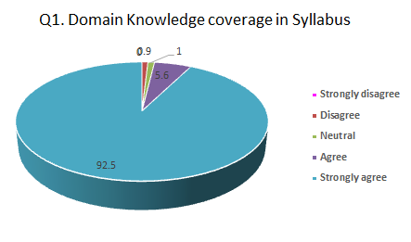
Sno | Parameter related to Curricula/Syllabi | Percentage of Feedback on the Parameter
Sno | Parameter related to Curricula/Syllabi | Strongly Agree | Agree | Neutral | Disagree | Strongly Disagree
2 | Mix of Theory and Practical Courses | 96.8 | 1 | 2 | 0.1 | 0.1

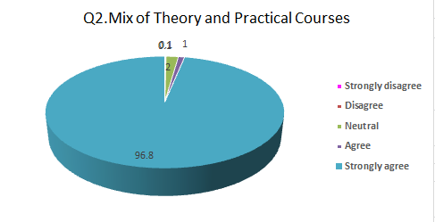
Sno | Parameter related to Curricula/Syllabi | Percentage of Feedback on the Parameter
Sno | Parameter related to Curricula/Syllabi | Strongly Agree | Agree | Neutral | Disagree | Strongly Disagree
3 | Coverage of Problem Solving and Analytical Skills | 94.63 | 2.1 | 2.5 | 0.57 | 0.2

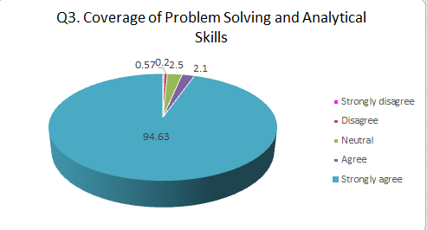
Sno | Parameter related to Curricula/Syllabi | Percentage of Feedback on the Parameter
Sno | Parameter related to Curricula/Syllabi | Strongly Agree | Agree | Neutral | Disagree | Strongly Disagree
4 | Attainment of Learning Outcomes | 98.1 | 0.9 | 0.4 | 0.6 | 0

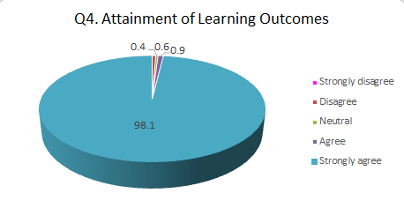
Sno | Parameter related to Curricula/Syllabi | Percentage of Feedback on the Parameter
Sno | Parameter related to Curricula/Syllabi | Strongly Agree | Agree | Neutral | Disagree | Strongly Disagree
5 | Coverage scope of Entrepreneurship Skills / Human Values and Ethics | 92.02 | 2.68 | 3.1 | 2.2 | 0

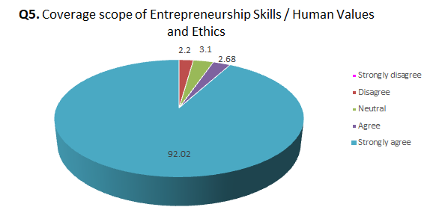

Sno | Parameter related to Curricula/Syllabi | Percentage of Feedback on the Parameter
Sno | Parameter related to Curricula/Syllabi | Strongly Agree | Agree | Neutral | Disagree | Strongly Disagree
6 | Scope of Participative Learning and Experiential Learning | 93.9 | 3.9 | 1.8 | 0.4 | 0

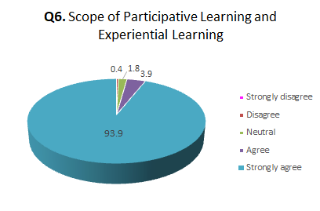

Sno | Parameter related to Curricula/Syllabi | Percentage of Feedback on the Parameter
Sno | Parameter related to Curricula/Syllabi | Strongly Agree | Agree | Neutral | Disagree | Strongly Disagree
7 | Assessment and Evaluation Process | 97.3 | 0.8 | 1.4 | 0.5 | 0

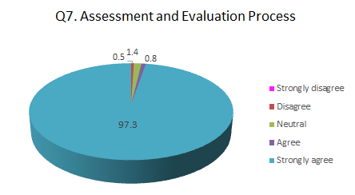

Sno | Parameter related to Curricula/Syllabi | Percentage of Feedback on the Parameter
Sno | Parameter related to Curricula/Syllabi | Strongly Agree | Agree | Neutral | Disagree | Strongly Disagree
8 | Scope of Innovation / Leadership and Communication Skills | 93.5 | 2.2 | 1.8 | 2.5 | 0

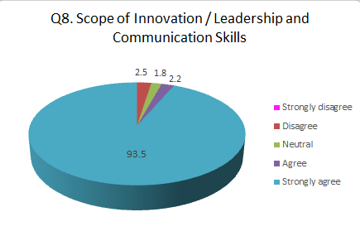
Sno | Parameter related to Curricula/Syllabi | Percentage of Feedback on the Parameter
Sno | Parameter related to Curricula/Syllabi | Strongly Agree | Agree | Neutral | Disagree | Strongly Disagree
9 | Choice of Course through CBCS/Value Added Courses/Electives | 96.56 | 1.4 | 1.5 | 0.5 | 0

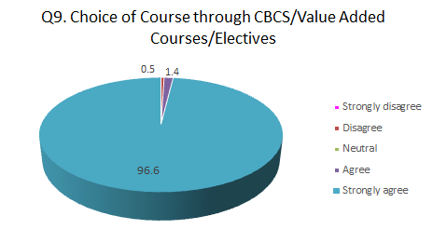

Sno | Parameter related to Curricula/Syllabi | Percentage of Feedback on the Parameter
Sno | Parameter related to Curricula/Syllabi | Strongly Agree | Agree | Neutral | Disagree | Strongly Disagree
10 | Opportunities for Co-curricular and Extra Curricular activities | 94.4 | 3.1 | 1.8 | 0.5 | 0.2

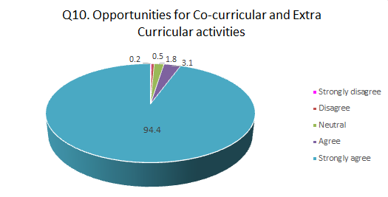

  - ANALYSIS
- 98.47% students found curriculum to be very effective in enhancing the skills, team work, developing analytical skills and constructive learning. Most of the students are of the opinion that the syllabus gives indepth knowledge on the discipline and the syllabi covers the industrial requirement and emerging technologies. Few of the students felt that more courses covering the entrepreneurship could be made available. Overall, the syllabus was able to meet the expectations of the students.
- The students suggested that more number of projects can be facilitated through TBI.
- The students shared their concern of not being able to attend physical internships and certifications for their credit accumulation.
- Some students raised concern of whether placements would be affected due to the pandemic situation.
- Analysis of Faculty Feedback

  - Questions in the Feedback Template
Q1 | Rate your opinion on the relevancy/ sufficiency of the courses on latest technology trends.
Q2 | Does the curriculum have good mix of theory and laboratory aspects of courses
Q3 | Rate the liberty you are given to contribute your ideas in course revision, curriculum design, development and innovative pedagogical initiatives
Q4 | Does the curriculum include value added courses/ soft skill training/ domain specific electives for enhancing constructive learning?
Q5 | Rate your satisfaction on the process followed for the periodic curriculum revision by the institution
Q6 | Your view on whether the experiences gained through Projects/ Internships/ certifications facilitated more Employability skills/ Communication skills/ confidence in students.
Q7 | Does the curriculum have scope for acquiring strong knowledge and intellect on the specific domains through electives/CBCS/ Value Added Courses/ Certifications, etc
Q8 | Do you think that the students are given opportunities to demonstrate their innovative skills, leadership skills and communication skills
Q9 | Does the curriculum clearly state the learning outcomes and the process of assessment and evaluation?
Q10 | Are the academic initiatives of the department contributing towards achieving the Mission and Vision of the institution

  - Analysis Report
Sno | Parameter related to Curricula/Syllabi | Percentage of Feedback on the Parameter
Sno | Parameter related to Curricula/Syllabi | Strongly Agree | Agree | Neutral | Disagree | Strongly Disagree
1 | Domain Knowledge coverage in Syllabus | 92.6 | 3.3 | 4.1 | 0 | 0

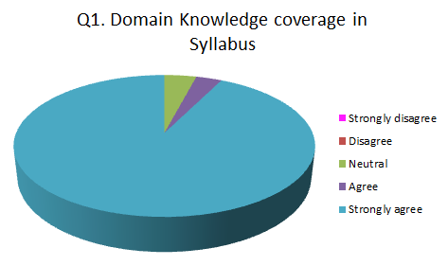

Sno | Parameter related to Curricula/Syllabi | Percentage of Feedback on the Parameter
Sno | Parameter related to Curricula/Syllabi | Strongly Agree | Agree | Neutral | Disagree | Strongly Disagree
2 | Mix of Theory and Practical Courses | 93.5 | 4.6 | 1.9 | 0 | 0

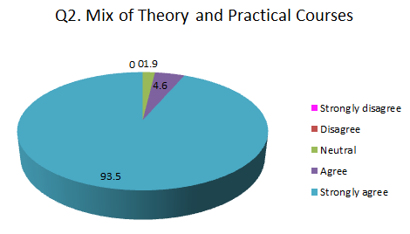

Sno | Parameter related to Curricula/Syllabi | Percentage of Feedback on the Parameter
Sno | Parameter related to Curricula/Syllabi | Strongly Agree | Agree | Neutral | Disagree | Strongly Disagree
3 | Inputs given for syllabus Revision | 97.7 | 1.8 | 0.5 | 0 | 0

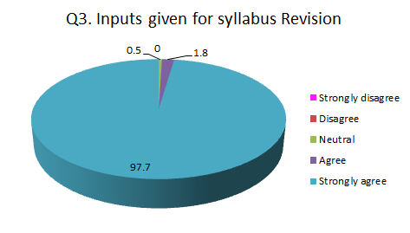

Sno | Parameter related to Curricula/Syllabi | Percentage of Feedback on the Parameter
Sno | Parameter related to Curricula/Syllabi | Strongly Agree | Agree | Neutral | Disagree | Strongly Disagree
4 | Scope for constructive Learning | 94.36 | 3.74 | 1.9 | 0 | 0

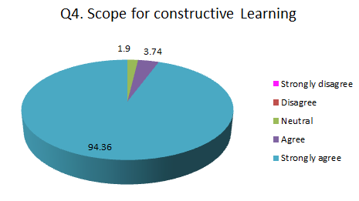

Sno | Parameter related to Curricula/Syllabi | Percentage of Feedback on the Parameter
Sno | Parameter related to Curricula/Syllabi | Strongly Agree | Agree | Neutral | Disagree | Strongly Disagree
5 | Frequency of Curriculum Revision | 98 | 2 | 0 | 0 | 0

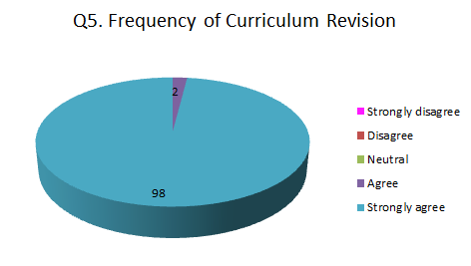

Sno | Parameter related to Curricula/Syllabi | Percentage of Feedback on the Parameter
Sno | Parameter related to Curricula/Syllabi | Strongly Agree | Agree | Neutral | Disagree | Strongly Disagree
6 | Facilitation of Employability skills, Communication skills | 95.8 | 2.5 | 1.7 | 0.2 | 0

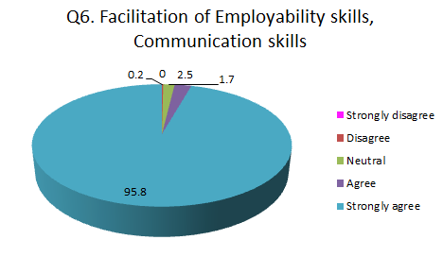

Sno | Parameter related to Curricula/Syllabi | Percentage of Feedback on the Parameter
Sno | Parameter related to Curricula/Syllabi | Strongly Agree | Agree | Neutral | Disagree | Strongly Disagree
7 | Choice of Course through CBCS/Value Added Courses/Electives | 96.7 | 1.4 | 1.9 | 0.2 | 0

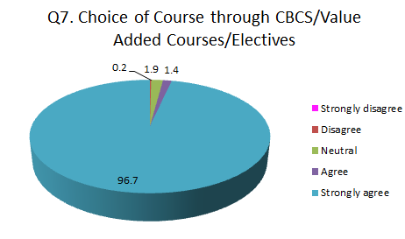

Sno | Parameter related to Curricula/Syllabi | Percentage of Feedback on the Parameter
Sno | Parameter related to Curricula/Syllabi | Strongly Agree | Agree | Neutral | Disagree | Strongly Disagree
8 | Scope of Innovation / Leadership and Communication Skills | 94.3 | 2.6 | 3.1 | 0.1 | 0

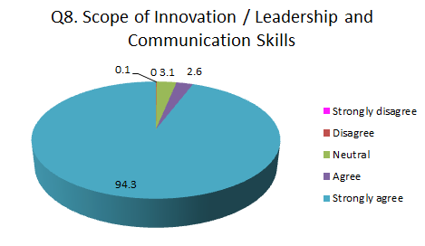

Sno | Parameter related to Curricula/Syllabi | Percentage of Feedback on the Parameter
Sno | Parameter related to Curricula/Syllabi | Strongly Agree | Agree | Neutral | Disagree | Strongly Disagree
9 | Attainment of Learning Outcomes | 93.69 | 4.6 | 1.7 | 0 | 0

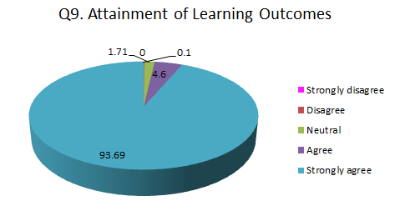

Sno | Parameter related to Curricula/Syllabi | Percentage of Feedback on the Parameter
Sno | Parameter related to Curricula/Syllabi | Strongly Agree | Agree | Neutral | Disagree | Strongly Disagree
10 | Contribution towards Mission and vision of Institution | 94.6 | 2.5 | 2.9 | 0.3 | 0

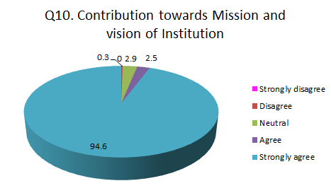

  - ANALYSIS
- The majority of the faculty members were satisfied with the initiatives taken by the institute towards the design and development of curriculum.
- The suggested revisions of the faculty are presented in the Board of Studies of respective departments and the same is approved by the Academic Council.
- Some Faculty suggested the inclusion of courses with hands on lab experiences would enhance the learning of students
- Faculty suggested the use of a score based quantitative and qualitative assessment of their performance and suggested a cash reward would be motivating.
- Analysis of Alumni Feedback

  - Questions in the Feedback Template
Q1 | Rate your opinion on the relevancy/ sufficiency of the courses meeting the industry requirements?
Q2 | Rate whether the experiences gained through projects/ internships/ certifications facilitated more employability skills/ communication skills/ confidence in you.
Q3 | How effective is the Curriculum in developing analytical and problem-solving skills
Q4 | Does the curriculum include value added courses/ soft skill training/ domain specific electives for enhancing constructive learning.
Q5 | Rate the scope of the syllabus in enhancing entrepreneurship skills/ lifelong learning/ human values and ethics.
Q6 | Rate the scope of the curriculum in developing the following attributes - creativity, leadership, innovation, self-motivation, workplace ethics, social responsibility
Q7 | The curriculum facilitates in acquiring the learning outcomes of the programme of study.
Q8 | Your opinion on the various platforms and opportunities facilitated by the Institution to achieve your goals.
Q9 | Is the curriculum facilitating enhancement of practical competencies as needed by the industry?
Q10 | Rate your participation in the various academic initiatives of the Institution.

3.2 Analysis Report

Sno | Parameter related to Curricula/Syllabi | Percentage of Feedback on the Parameter
Sno | Parameter related to Curricula/Syllabi | Strongly Agree | Agree | Neutral | Disagree | Strongly Disagree
1 | Syllabus meets Industry Standards | 79.5 | 18.4 | 2.1 | 0 | 0

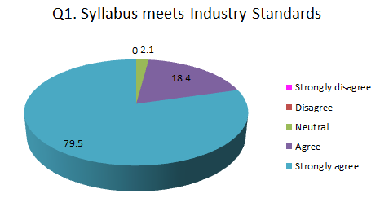

Sno | Parameter related to Curricula/Syllabi | Percentage of Feedback on the Parameter
Sno | Parameter related to Curricula/Syllabi | Strongly Agree | Agree | Neutral | Disagree | Strongly Disagree
2 | Scope of Employability and Communication Skill Development | 82.4 | 15.5 | 2.1 | 0.5 | 0

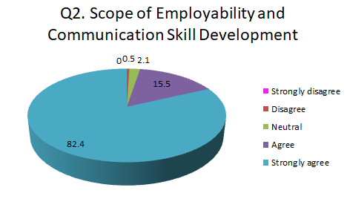

Sno | Parameter related to Curricula/Syllabi | Percentage of Feedback on the Parameter
Sno | Parameter related to Curricula/Syllabi | Strongly Agree | Agree | Neutral | Disagree | Strongly Disagree
3 | Development of Analytical and Problem Solving Skills | 78.9 | 17.5 | 3.2 | 0.4 | 0

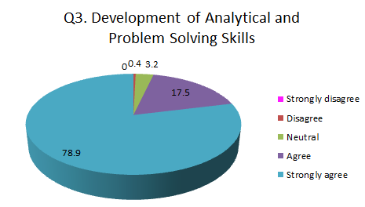

Sno | Parameter related to Curricula/Syllabi | Percentage of Feedback on the Parameter
Sno | Parameter related to Curricula/Syllabi | Strongly Agree | Agree | Neutral | Disagree | Strongly Disagree
4 | Scope of Constructive Learning | 82 | 16.5 | 1.5 | 0 | 0

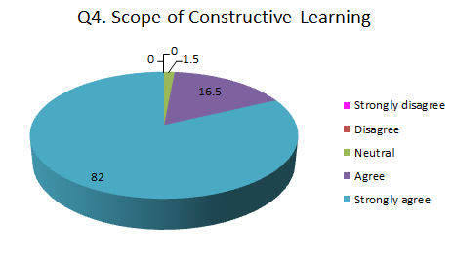

Sno | Parameter related to Curricula/Syllabi | Percentage of Feedback on the Parameter
Sno | Parameter related to Curricula/Syllabi | Strongly Agree | Agree | Neutral | Disagree | Strongly Disagree
5 | Coverage scope of Entrepreneurship Skills / Human Values and Ethics | 84.7 | 14.1 | 1.2 | 0.5 | 0

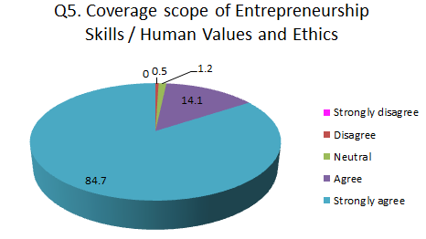

Sno | Parameter related to Curricula/Syllabi | Percentage of Feedback on the Parameter
Sno | Parameter related to Curricula/Syllabi | Strongly Agree | Agree | Neutral | Disagree | Strongly Disagree
6 | Scope for Holistic Development | 82 | 16.5 | 1.5 | 0 | 0

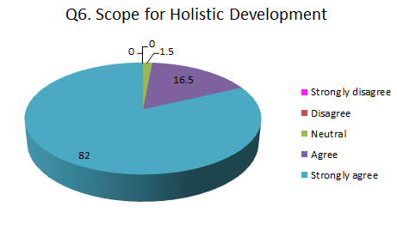

Sno | Parameter related to Curricula/Syllabi | Percentage of Feedback on the Parameter
Sno | Parameter related to Curricula/Syllabi | Strongly Agree | Agree | Neutral | Disagree | Strongly Disagree
7 | Attainment of Learning Outcomes | 82 | 16.5 | 1.5 | 0 | 0

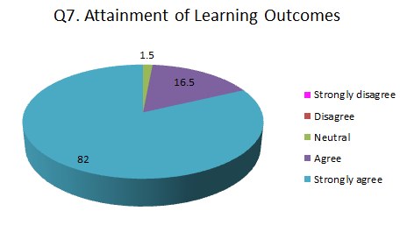

Sno | Parameter related to Curricula/Syllabi | Percentage of Feedback on the Parameter
Sno | Parameter related to Curricula/Syllabi | Strongly Agree | Agree | Neutral | Disagree | Strongly Disagree
8 | Opportunities for overall Development | 87.2 | 10.3 | 2.2 | 0.3 | 0

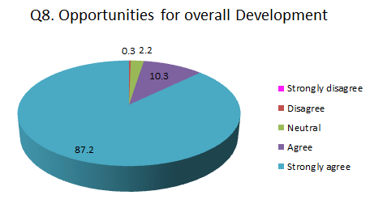

Sno | Parameter related to Curricula/Syllabi | Percentage of Feedback on the Parameter
Sno | Parameter related to Curricula/Syllabi | Strongly Agree | Agree | Neutral | Disagree | Strongly Disagree
9 | Enhancement of Practical competencies | 82 | 16.5 | 1.5 | 0 | 0

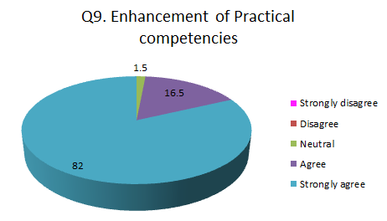

Sno | Parameter related to Curricula/Syllabi | Percentage of Feedback on the Parameter
Sno | Parameter related to Curricula/Syllabi | Strongly Agree | Agree | Neutral | Disagree | Strongly Disagree
10 | Participation in Academic Initiatives | 80.2 | 19 | 0.8 | 0 | 0

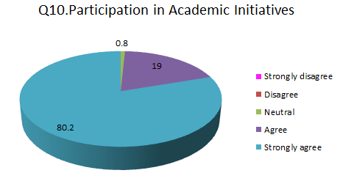

3.3 ANALYSIS
- The majority of the Alumni are satisfied with the process of Curriculum design and development. Maximum number of Alumni opined that Curriculum is effective in developing analytical skills & communication skills.
- Alumni suggested the introduction of design thinking and product thinking skills to the students would enhance their overall development and placement opportunities.
- Alumni suggested that opportunities can be created for them to up skill/re-skill for all industry requirements from time to time.
- Some of the alumnae insist on the requirement of multidisciplinary knowledge for better product understanding and generate new ideas.
- Alumni appreciated the Semester Abroad Programme for providing international exposure and learning experience to students.

- Analysis of Employer Feedback

  - Questions in the Feedback Template
Q1 | Rate your opinion on the relevancy/ sufficiency of the courses meeting the industry requirements?
Q2 | Rate the applicability of the tools/activities/case studies presented in the curriculum facilitating more employability skills among graduates.
Q3 | How effective is the Curriculum in developing analytical and problem-solving skills
Q4 | Does the curriculum include value added courses/ soft skill training/ domain specific electives for enhancing constructive learning.
Q5 | Rate the scope of the syllabus in enhancing entrepreneurship skills/ lifelong learning/ human values and ethics.
Q6 | Curriculum reflects current trends and practices in the respective disciplines.
Q7 | Does the curriculum effectively cover topics on fundamentals and latest technology?
Q8 | The academic initiatives of the institution contributes towards achieving the Mission and Vision of the institution
Q9 | Rate the proficiency of our graduates to adapt to industry requirements
Q10 | The curriculum facilitates an overall holistic development of the student?

4.2 Analysis Report
Sno | Parameter related to Curricula/Syllabi | Percentage of Feedback on the Parameter
Sno | Parameter related to Curricula/Syllabi | Strongly Agree | Agree | Neutral | Disagree | Strongly Disagree
1 | Curriculum meets Industry Standards | 79.4 | 18.5 | 2.1 | 0 | 0

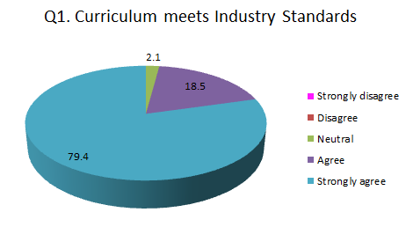

Sno | Parameter related to Curricula/Syllabi | Percentage of Feedback on the Parameter
Sno | Parameter related to Curricula/Syllabi | Strongly Agree | Agree | Neutral | Disagree | Strongly Disagree
2 | Facilitation of tools for Employability | 76.7 | 20.5 | 2.8 | 0 | 0

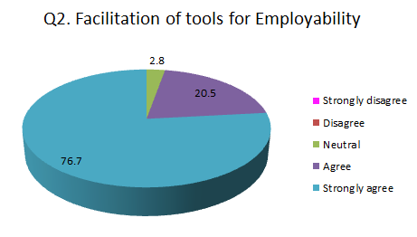

Sno | Parameter related to Curricula/Syllabi | Percentage of Feedback on the Parameter
Sno | Parameter related to Curricula/Syllabi | Strongly Agree | Agree | Neutral | Disagree | Strongly Disagree
3 | Scope for development of Problem Solving Skills | 79.3 | 18.5 | 2.1 | 0.1 | 0

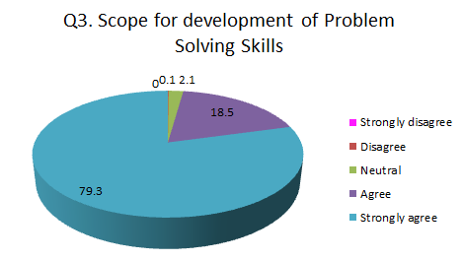

Sno | Parameter related to Curricula/Syllabi | Percentage of Feedback on the Parameter
Sno | Parameter related to Curricula/Syllabi | Strongly Agree | Agree | Neutral | Disagree | Strongly Disagree
4 | Scope for Constructive Learning | 73.8 | 21.5 | 4.7 | 0 | 0

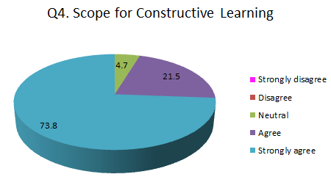

Sno | Parameter related to Curricula/Syllabi | Percentage of Feedback on the Parameter
Sno | Parameter related to Curricula/Syllabi | Strongly Agree | Agree | Neutral | Disagree | Strongly Disagree
5 | Coverage scope of Entrepreneurship Skills / Human Values and Ethics | 74.5 | 23.3 | 2.1 | 0.1 | 0

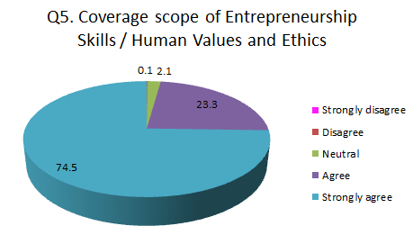

Sno | Parameter related to Curricula/Syllabi | Percentage of Feedback on the Parameter
Sno | Parameter related to Curricula/Syllabi | Strongly Agree | Agree | Neutral | Disagree | Strongly Disagree
6 | Domain Expertise | 80.5 | 15.5 | 3.5 | 0.5 | 0

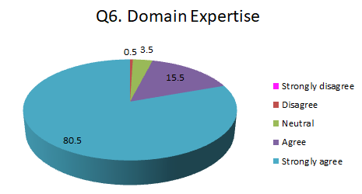

Sno | Parameter related to Curricula/Syllabi | Percentage of Feedback on the Parameter
Sno | Parameter related to Curricula/Syllabi | Strongly Agree | Agree | Neutral | Disagree | Strongly Disagree
7 | Coverage of Fundamentals and Technology | 81.8 | 14.5 | 3.7 | 0 | 0

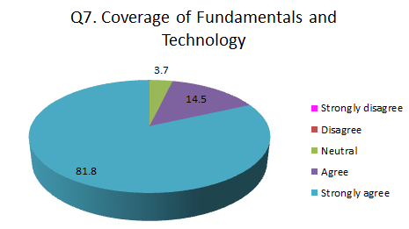

Sno | Parameter related to Curricula/Syllabi | Percentage of Feedback on the Parameter
Sno | Parameter related to Curricula/Syllabi | Strongly Agree | Agree | Neutral | Disagree | Strongly Disagree
8 | Contribution to the Vision and Mission of Institution | 90.4 | 9.4 | 0.2 | 0 | 0

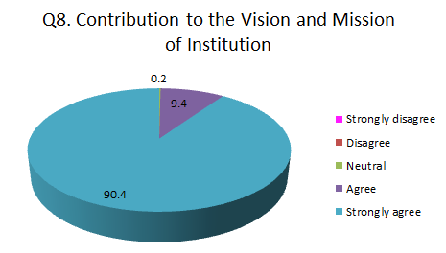

Sno | Parameter related to Curricula/Syllabi | Percentage of Feedback on the Parameter
Sno | Parameter related to Curricula/Syllabi | Strongly Agree | Agree | Neutral | Disagree | Strongly Disagree
9 | Industrial competitive Learning | 80.4 | 17.5 | 2.1 | 0 | 0

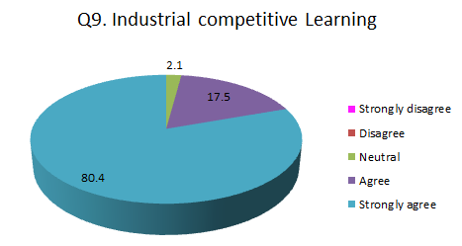

Sno | Parameter related to Curricula/Syllabi | Percentage of Feedback on the Parameter
Sno | Parameter related to Curricula/Syllabi | Strongly Agree | Agree | Neutral | Disagree | Strongly Disagree
10 | Opportunities for Holistic Development | 88.5 | 7.3 | 4.2 | 0 | 0

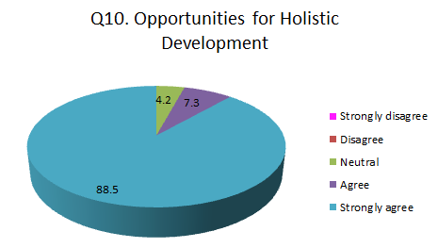

4.3. ANALYSIS
- The employers were Satisfied with the process of Curriculum design and development. An average 78% employers are strongly agree, 18% are agree with the Critical thinking ability and the skills were developed to the students based on current syllabus of the various programs. Also the majority of the employers have an opinion that the syllabus framed was socially relevant and suitable for the placements in job market.
- Experts forecasted the need of specialization programmes on current trends such as AI, Data Sciences for better placement prospects.
- Employer suggested the students should be extensively trained on design thinking.
- Employer suggested that the students should have more exposure to product building and domain expertise for high packages.

